**Stock Market Analysis**

**Data Source:**  [**https://www.kaggle.com/datasets/rockyjoseph/nifty-50-stock-market-data-2000-2023?resource=download**](https://www.kaggle.com/datasets/rockyjoseph/nifty-50-stock-market-data-2000-2023?resource=download)

**Tech companies’ dataset**: TCS, Wipro, Infosys

**Dataset is from Year:** 2020-2023

**Objectives:**

1)Analysing volatility

2)Drawdown percentage

3)recovery days

4)Number of days stock price closed above its previous day's close

5)CAGR

6)Highest Volume Month

7)Final Ranking

Volatility

Degree of variation of a trading price series over time.

Formula

Avg (day high-day low) over a period of time

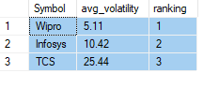Least volatility 🡪 least variations 🡪better the stock

Wipro🡪 least volatility

TCS🡪 most Volatility

Drawdown/fall in stock price

How much an investment or trading account is down from the peak before it recovers back to the peak

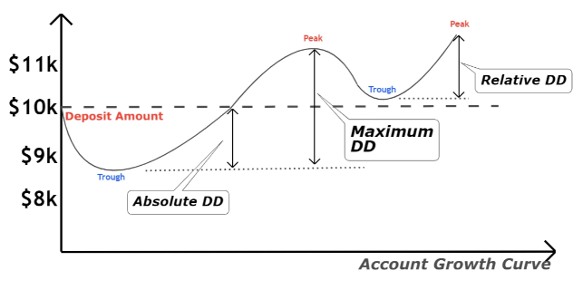

**Created a view containing max and min values of Closing stock price between 2020, feb to 2020, March for all three companies**

Drop view if Exists A3;

Create view A3 as (

Select Max([Close])as Max_C, Min([Close])as Min_C,Symbol from[dbo].[INFOSYS] where [Date] between '2020-02-01' and '2020-03-31'and [Close] is not null group by Symbol

Union

Select Max([Close])as Max_C,Min([Close]) as Min_C,Symbol from [dbo].[TATA CONSULTANCY SERVICES] where [Date] between '2020-02-01' and '2020-03-31'and [Close] is not null group by Symbol

Union

Select Max([Close])as Max_C,Min([Close])as Min_C,Symbol from[dbo].[WIPRO] where [Date] between '2020-02-01' and '2020-03-31'and [Close] is not null group by Symbol

)

**Calculated the drawdown for each company between 2020 feb to 2020 march**

Select Symbol,Max_C,Min_C ,round(((Min_C-Max_C)/Max_C),4)*100 as Drawdown from A3 ;

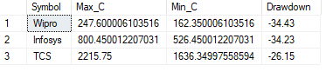

Wipro 🡪 max Drawdown

TCS 🡪 Min Drawdown

**Drawdown minimum is better.**

Recovery Days

Number of days taken by stocks after its fall ,to close above it’s peak value.

Creating temp table to store those dates where stock price is greater than the peak value stock price before covid

Select * into #Recovery_Date from

(

Select [Date],[Symbol]

from

(

Select [Date],Symbol,[Close],ROW_NUMBER() over ( order by[Date] asc)as rn

from [dbo].[INFOSYS]

where [Date] between '2020-03-23' and '2021-03-31' and [Close]>=(Select Max_C from A3 where [Symbol]='Infosys')

Union

Select [Date],Symbol,[Close],ROW_NUMBER() over ( order by[Date] asc)as rn

from [dbo].[TATA CONSULTANCY SERVICES]

where [Date] between '2020-03-19' and '2021-03-31' and [Close]>=(Select Max_C from A3 where [Symbol]='TCS')

Union

Select [Date],Symbol,[Close],ROW_NUMBER() over ( order by[Date] asc)as rn

from [dbo].[WIPRO]

where [Date] between '2020-03-19' and '2021-03-31' and [Close]>=(Select Max_C from A3 where [Symbol]='Wipro')

)as C

where C.rn=1

) as R

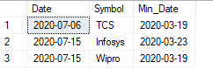

--adding new date column to our temp table where we store that date where we had our minimum Closing Amt for march

alter table #Recovery_Date add Min_Date Date

Update #Recovery_Date set [Min_Date]='2020-03-23' where Symbol='Infosys'

Update #Recovery_Date set [Min_Date]='2020-03-19' where Symbol='TCS'

Update #Recovery_Date set [Min_Date]='2020-03-19' where Symbol='Wipro'

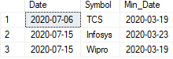

Select datediff(day,Min_Date,[Date])as Recovery_Days,Symbol from #Recovery_Date

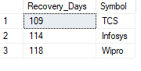

Lower Recovery Days**🡪** Better🡪Faster Recovery

**Thus, TCS recovered fastest**

**Strength**

Number of days Stock price closed above its previous day closing price.

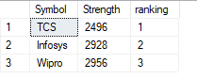

TCS🡪Max Strength 🡪Better Stock

**CAGR(Compound Annual Growth Rate)**

 CAGR (Compound Annual Growth Rate) measures your investments' average annual growth over a given period. It shows you the average rate of return on your investments over a year. CAGR is a helpful tool for investors because it precisely measures investment growth (or decline) over time.

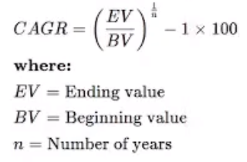

2002-08-13 🡪Start Date

2023-06-22🡪End Date

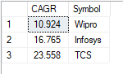

**Wipro🡪lowest CAGR**

**TCS🡪Highest CAGR 🡪Better Stock**

**Maximum Volume Month**

Volume in the stock market means the total number of shares traded in a specified time frame. This would include every share that is bought and sold during the time period in review.

Calculation: Months where volume was highest.

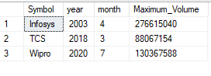

**Final Ranking Table**

|  |  |  |  |  |  |
| --- | --- | --- | --- | --- | --- |
| Symbol | Volatility | Drawdown | Recovery | Strength | CAGR |
| TCS | 3 | 1 | 1 | 3 | 1 |
| Infosys | 2 | 2 | 2 | 2 | 2 |
| Wipro | 1 | 3 | 3 | 1 | 3 |